|  |  |  |
| --- | --- | --- |
| Project Design Document | |  | | --- | | *4/12/2021*  Davide Coffaro | |

|  |  |  |  |
| --- | --- | --- | --- |
| Project Concept | | | |
| 1 **Player Control** |  | You control a   |  | | --- | | *Spaceship* | | in this   |  |  | | --- | --- | | *top Down* | game | |
|  | where   |  | | --- | | *Arrow keys* | | *Power keys* | | *Shoot key* | | makes the player   |  | | --- | | *Move in its bottom part of the screen in all directions* | | *Use power Ups and power Downs collected* | | *Shoot forward in the player's direction* | |

|  |  |  |  |  |  |  |  |  |  |  |  |  |  |  |  |  |  |  |
| --- | --- | --- | --- | --- | --- | --- | --- | --- | --- | --- | --- | --- | --- | --- | --- | --- | --- | --- |
| 2 **Basic**  **Gameplay** |  | During the game,   |  |  | | --- | --- | | *Enemies' spaceships and obstacles* | appear | |  | Shoot | | *Opponent's spaceship* | Move | |  | Shoot | | *points objects, power ups and downs* | Appear | | from   |  | | --- | | *Center of the screen (for both player)* | | *Its position, toward player's spaceship* | | *Its top part of the screen* | | *Its position, forward direction* | | *Center of the screen (for both player)* | |
|  | and the goal of the game is to   |  | | --- | | *Destroy opponent's spaceship or collect more points than the opponent player at the end of the timer of the game.* | | |

|  |  |  |  |  |  |  |  |  |  |  |  |
| --- | --- | --- | --- | --- | --- | --- | --- | --- | --- | --- | --- |
| 3 **Sound**  **& Effects** |  | There will be sound effects   |  | | --- | | *When players or enemies' spaceships shoot* | | *When player's spaceship is hit by a shot* | | *when enemies' spaceships are destroyed* | | *When points objects are collected* | | *When power ups or downs are collected* | | and particle effects   |  | | --- | | *When enemies' spaceships or obstacles are destroyed* | | *When player's spaceship is destroyed* | | *When a point object is destroyed* | |
|  | [*optional*] There will also be   |  | | --- | | *- particle effect on spaceships engines*  *- Background sound during the game*  *- a scrolling background of the space*  *- sound during the collection of some points object* | | |

|  |  |  |  |  |  |  |  |  |  |  |  |
| --- | --- | --- | --- | --- | --- | --- | --- | --- | --- | --- | --- |
| 4 **Gameplay**  **Mechanics** |  | As the game progresses,   |  | | --- | | *Enemies’ spaceships move toward a predefined position of the screen* | | *Obstacles move vertically from the center of the screen to the top/bottom side* | | *Points objects move vertically from the center of the screen to the top/bottom side* | | *Power ups and downs are used* | | making it   |  | | --- | | *The position from where they start to shoot* | | *The player could avoid or destroy them* | | *The player could collect them or not* | | *Add different behavior to the player's spaceship or to the opponent's spaceship* | |
|  | [*optional*] There will also be   |  | | --- | |  | | |

|  |  |  |  |  |  |  |  |  |  |  |  |  |  |  |  |  |  |  |  |  |  |  |  |  |  |
| --- | --- | --- | --- | --- | --- | --- | --- | --- | --- | --- | --- | --- | --- | --- | --- | --- | --- | --- | --- | --- | --- | --- | --- | --- | --- |
| 5 **User**  **Interface** |  | The   |  | | --- | | *Score* | | *Score* | | *Score* | | *Lives* | | *Lives* | | *Lives* | | *Timer* | | will   |  | | --- | | *Increase* | | *Increase* | | *Decrease* | | *Increase* | | *Decrease* | | *Decrease* | | *Decrease* | | whenever   |  | | --- | | *points objects are collected by the player* | | *Enemies or obstacles are destroyed* | | *points objects are destroyed* | | *Special points object collected* | | *Enemies' or opponent's spaceship shots hit the player's spaceship* | | *Obstacle hits the player's spaceship* | | *Every second is passed* | |
|  | At the start of the game, the title   |  |  | | --- | --- | | *Get the space title with Input controller for 2 players* | will appear | | | and the game will end when   |  | | --- | | *Player spaceship runs out of lives or timer ends* | |

|  |  |  |  |
| --- | --- | --- | --- |
| 6 **Other Features** |  | |  | | --- | | *- A cooldown bar that Increases Its value when player shoots continuously*  *- when a player run out of lives the opponent must keep play until the timer ends, If It runs out of lives the computer wins and the 2 players lose.* | |

# 

# Project Timeline

|  |  |  |
| --- | --- | --- |
| Milestone | Description | Due |
| **#1** | |  | | --- | | * *Player1 movement In Its side of the screen* * *Player2 movement In Its side of the screen* * *player1 shoots* * *player2 shoots* | | |  | | --- | | *4/14* | |
| **#2** | |  | | --- | | *- Creation of enemies' spaceship and move them to the predefined position (for both players): spelled with 1 and 2 to understand which player side they are referred*  *- enemies' spaceship1 shoot toward player1*  *- enemies' spaceship2 shoot toward player2*  *- destroy enemy1's spaceship when hit by player1 shot*   * *score1 Increase after previous point* * *show score1 In the UI*   *- destroy enemy2's spaceship when hit by player2 shot*   * *score2 Increase after previous point* * *show score2 In the UI* | | |  | | --- | | *4/19* | |
| **#3** | |  | | --- | | * *creation of obstacles and move them vertically to the top/bottom side (for both players): spelled with 1 and 2 to understand which player side they are referred* * *destroy obstacles1 when hit by player1's shot* * *score1 Increase after previous point* * *destroy obstacles2 when hit by player2's shot* * *score2 Increase after previous point* * *show lives1 In the UI* * *show lives2 In the UI* * *Decrease lives when:*   *A player is hit by a shot*  *A player is hit by an obstacle*  *- show timer in the UI*  *- decrease timer*  *- end game when timer is over*  *- end game when a player is out of lives* | | |  | | --- | | *4/26* | |
| **#4** | |  | | --- | | * *Creation of points objects and move them vertically to the top/bottom side (for both players): spelled with 1 and 2 to understand which player side they are referred* * *Destroy points objects1 collected on collision with player1* * *score1 Increase after previous point* * *destroy points objects2 collected on collision with player2* * *score2 Increase after previous point* * *destroy points objects1 when hit by player1's shot* * *score1 decrease after previous point* * *destroy points objects2 when hit by player2's shot* * *score2 decrease after previous point* * *Particle effects on enemies' spaceship destruction* * *particle effect on obstacles destruction* * *particle effect on player's spaceship destruction* * *particle effect on points objects destruction* | | |  | | --- | | *5/3* | |
| **#5** | |  | | --- | | * *creation of power ups and downs and move them vertically to the top/bottom side (for both players): spelled with 1 and 2 to understand which player side they are referred* * *destroy power ups and downs1 collected on collision with player1* * *show collected power ups and downs names in the UI1* * *destroy power ups and downs2 collected on collision with player2* * *show collected power ups and downs names in the UI2* * *manage power ups and downs behavior* * *using power ups and downs1 collected with all different behavior* * *using power ups and downs2 collected with all different behavior* * *UI with title of the game and input controller for the two players and a button to start to play* | | |  | | --- | | *5/10* | |
| **Backlog** | |  | | --- | | * *Sound on enemies' spaceship destruction* * *Sound on enemies' shots* * *Sound on players' shots* * *Sound on players' spaceship hit by a shot* * *Sound on points object collected by a player* * *Sound on power ups and downs collected by a player* * *Manage maximum power ups and down collected* * *Create a better UI for power ups and downs collected* * *lives Increase when special points object are collected* * *when a player runs out of lives the opponent must keep play until the timer Is over, If It loses the computer will win the game* * *a cooldown bar that Increases Its value when player shoots continuously* * *particle effect on spaceships engines* * *background sound during the game* * *a scrolling background of the space* * *a sound during the collection of some points objects* * *Feature on backlog - not a part of the minimum viable product* | | |  | | --- | | *5/24* | |

# Project Sketch

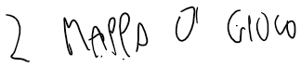

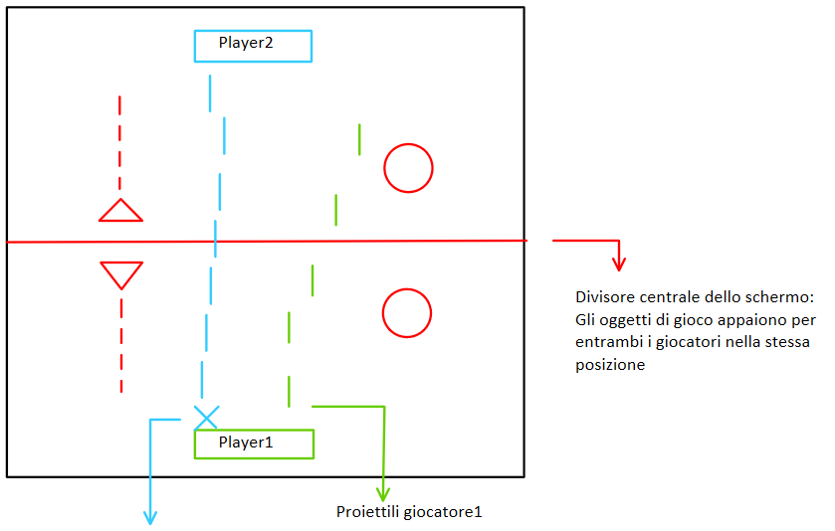

Colpito giocatore 1 con proiettili del giocatore2

Interfaccia utente della parte di schermo di 1 giocatore

